**12.DYNAMICALLY INITIALIZE AND PRINT ARRAY ELEMENTS**

Program:

#include<stdio.h>

int main()

{

int n,a[50],i;

printf("enter size of array");

scanf("%d",&n);

for(i=0;i<n;i++)

{

printf("enter element %d=", i+1);

scanf("%d",&a[i]);

}

printf("array elements are\n");

for(i=0;i<n;i++)

printf("%3d",a[i]);

return 0;

}

Output:

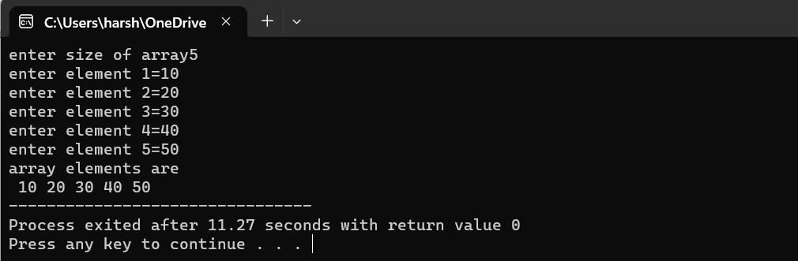

**13.SUM ARRAY ELEMENTS**

Program:

#include<stdio.h>

int main()

{

int n,a[50],i,s=0;

printf("enter size of array");

scanf("%d",&n);

for(i=0;i<n;i++)

{

printf("enter element %d=", i+1);

scanf("%d",&a[i]);

s=s+a[i];

}

printf("sum=%d",s);

return 0;

}

Output:

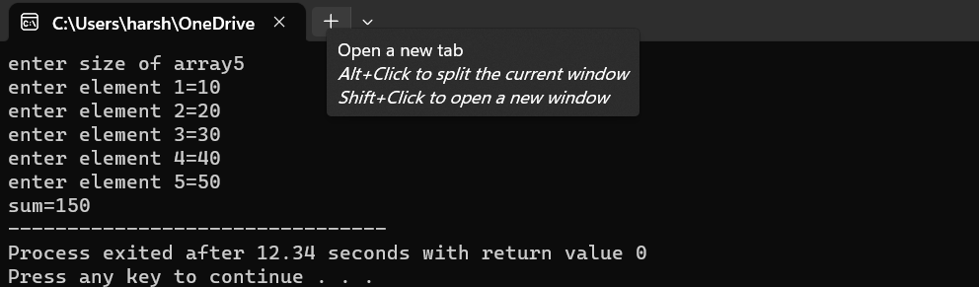

**14.SUM OF ODD AND EVEN NUMBERS IN THE ARRAY**

Program:

#include<stdio.h>

int main()

{

int a[50],n,es=0,os=0,i;

printf("enter size of the array");

scanf("%d",&n);

for(i=0;i<n;i++)

{

printf("enter element %d ",i+1);

scanf("%d",&a[i]);

}

for(i=0;i<n;i++)

{

if(i%2==0)

es=es+a[i];

else

os=os+a[i];

}

printf("evensum=%d\noddsum=%d",es,os);

return 0;

}

Output:

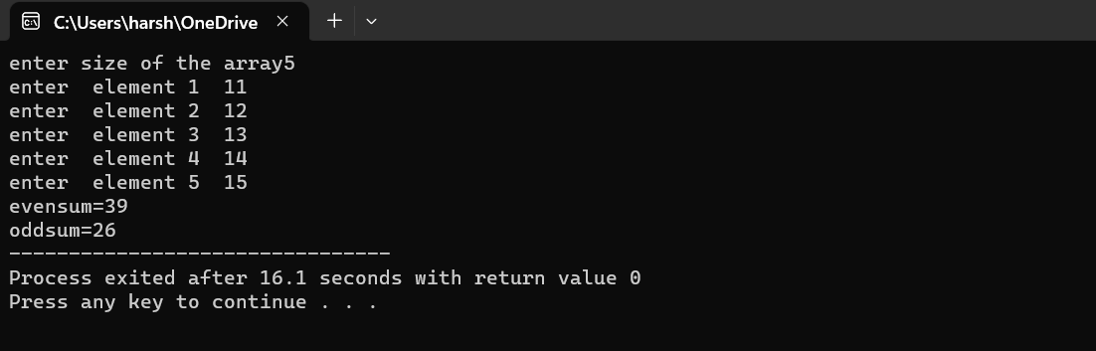

**15.INSERTING AN ELEMENT IN AN ARRAY**

Program:

#include<stdio.h>

int main()

{

int i,a[50],n,x,p;

printf("enter array size");

scanf("%d",&n);

printf("enter %d values\n",n);

for(i=0;i<n;i++)

scanf("%d",&a[i]);

printf("enter number to be inserted");

scanf("%d",&x);

printf("enter insert position");

scanf("%d",&p);

for(i=n;i>=p;i--)

{

a[i]=a[i-1];

}

a[p]=x;

n++;

for(i=0;i<n;i++)

printf("%3d",a[i]);

return 0;

}

Output:

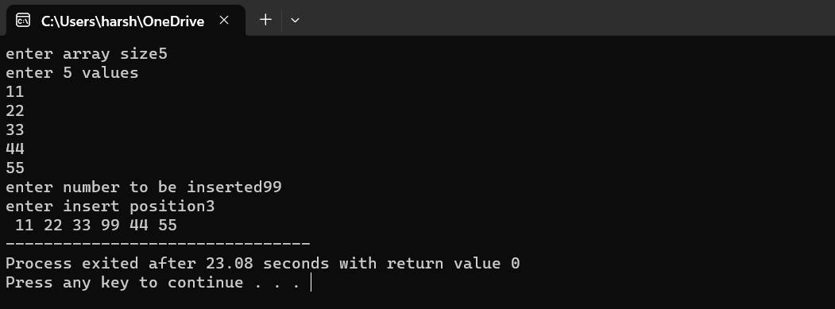

**16.DELETE AN ELEMENT IN THE ARRAY**

Program:

#include<stdio.h>

int main()

{

int a[10],i,j,n,x;

printf("enter array size");

scanf("%d",&n);

printf("enter %d values\n",n);

for(i=0;i<n;i++)

scanf("%d",&a[i]);

printf("enter number to be deleted");

scanf("%d",&x);

for(i=0;i<n;i++)

{

if(a[i]==x)

{

for(j=i;j<n;j++)

{

a[j]=a[j+1];

}

n--;

}

}

for(i=0;i<n;i++)

printf("%3d",a[i]);

}

Output:

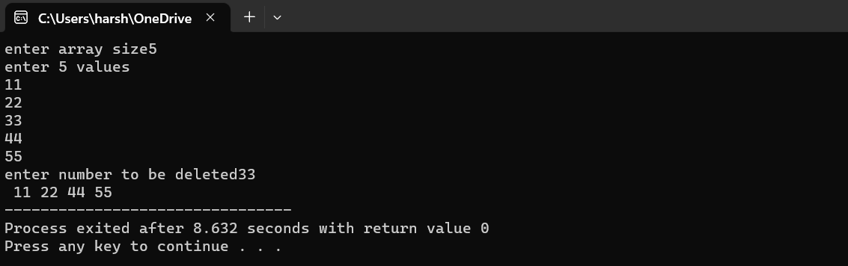

17.MERGING TWO ARRYS

Program:

#include<stdio.h>

int main()

{

int a[50],b[50],c[100],m,n,i,j;

printf("enter size of 1st array");

scanf("%d",&m);

printf("enter size of 2nd array");

scanf("%d",&n);

printf("enter %d first array elements\n",m);

for(i=0;i<m;i++)

scanf("%d",&a[i]);

printf("enter %d second array elements\n",n);

for(i=0;i<n;i++)

scanf("%d",&b[i]);

for(i=0;i<m;i++)

{

c[i]=a[i];

}

j=i;

for(i=0;i<n;i++)

{

c[j]=b[i];

j++;

}

for(i=0;i<m+n;i++)

printf("%3d",c[i]);

return 0;

}

Output:

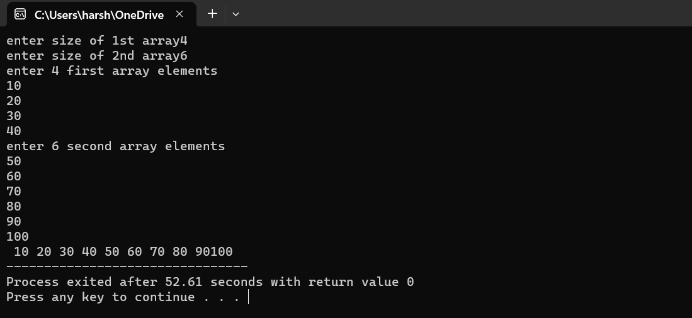

18.FINDING DUPLICATE ELEMENTS

Program:

#include<stdio.h>

int main()

{

int a[100],i,j,n,c=0;

printf("enter array size");

scanf("%d",&n);

printf("enter array elements\n");

for(i=0;i<n;i++)

scanf("%d",&a[i]);

for(i=0;i<n;i++)

{

c=0;

for(j=i+1;j<n;j++)

{

if(a[i]==a[j])

c++;

}

if(c!=0)

printf("\n%d\n",a[i]);

}

}

Output:

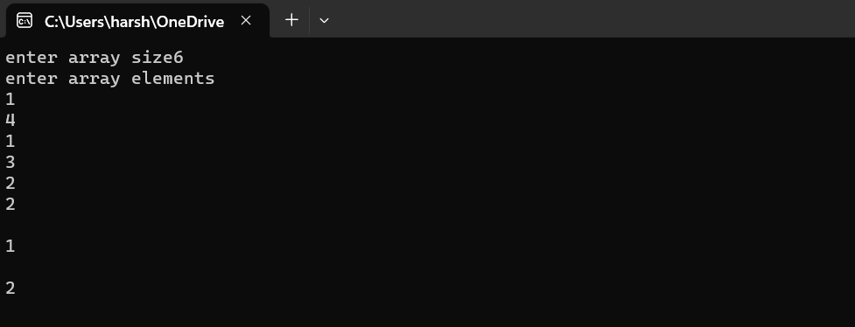

19.FINDING GREATEST ELEMENT IN AN ARRAY

Program:

#include<stdio.h>

int main()

{

int a[50],n,i,max;

printf("enter size of the array");

scanf("%d",&n);

for(i=0;i<n;i++)

{

printf("enter element %d ",i+1);

scanf("%d",&a[i]);

}

max=a[0];

for(i=0;i<n;i++)

{

if(max<a[i])

max=a[i];

}

printf("maximum element in array is %d",max);

return 0;

}

Output:

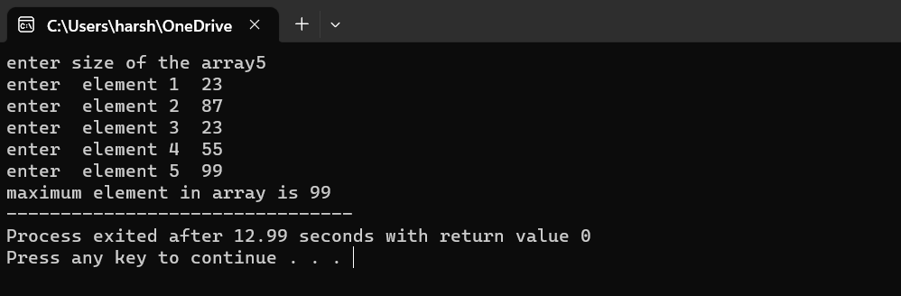

20.LINEAR SEARCH

Program:

#include<stdio.h>

int main()

{

int n,a[50],i,x;

printf("enter size of array");

scanf("%d",&n);

printf("enter elements\n");

for(i=0;i<n;i++)

{

scanf("%d",&a[i]);

}

printf("enter search element");

scanf("%d",&x);

for(i=0;i<n;i++)

{

if(a[i]==x)

printf("%d element found at %d ",x,i+1);

}

return 0;

}

Output:

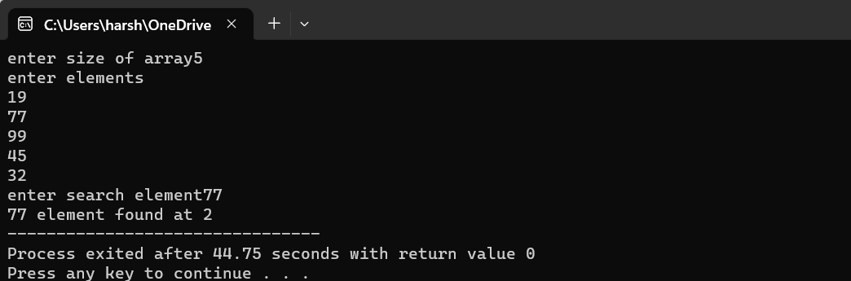

21BINARY SEARCH

Program:

#include<stdio.h>

int main()

{

int n,a[50],i,l,m,h,x;

printf("enter size of array");

scanf("%d",&n);

printf("enter elements\n");

for(i=0;i<n;i++)

{

scanf("%d",&a[i]);

}

printf("enter search element");

scanf("%d",&x);

l=0;

h=n;

while(l<=h)

{

m=(l+h)/2;

if(x==a[m])

{

printf("%d element fount at %d",x,m);

break;

}

else if(x<a[m])

h=m-1;

else

l=m+1;

}

return 0;

}

Output:

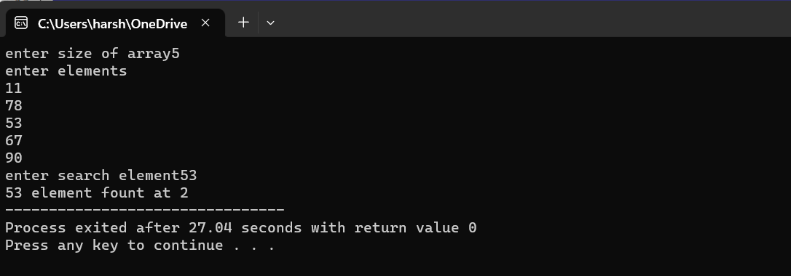

21.REVERSING THE GIVEN STRING

Program:

#include<stdio.h>

#include<string.h>

int main()

{

char str[50];

int i,l;

printf("enter string\n");

scanf("%s",&str);

l=strlen(str);

for(i=l-1;i>=0;i--)

printf("%c",str[i]);

}

Output:

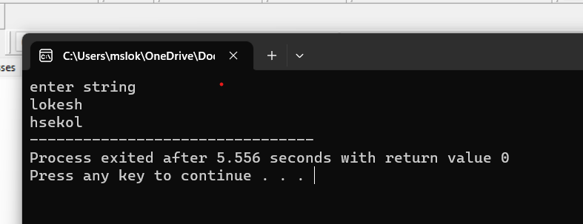

22.STRING PALINDROME

Program:

#include<stdio.h>

#include<string.h>

int main()

{

char str[50],c[50];

int i,l,s,e,j;

printf("enter string\n");

scanf("%s",&str);

e=strlen(str)-1;

s=0;

while(s<e)

{

if(str[s++]!=str[e--])

{

printf("not palindrome");

return 0;

}

}

printf("palindrome");

}

Output:

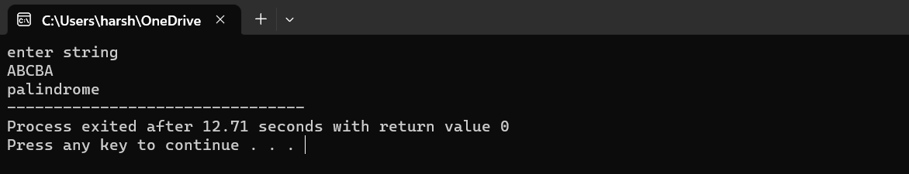

23.VOWELS COUNT IN A STRING

Program:

#include<stdio.h>

#include<string.h>

int main()

{

char s[50],c;

int i,l,n;

printf("enter string\n");

scanf("%s",&s);

n=strlen(s);

for(i=0;i<n;i++)

{

if(s[i]=='a' ||s[i]=='e' || s[i]=='i' ||s[i]=='o'||s[i]=='u')

c++;

}

printf("vowels count=%d",c);

}

Output:

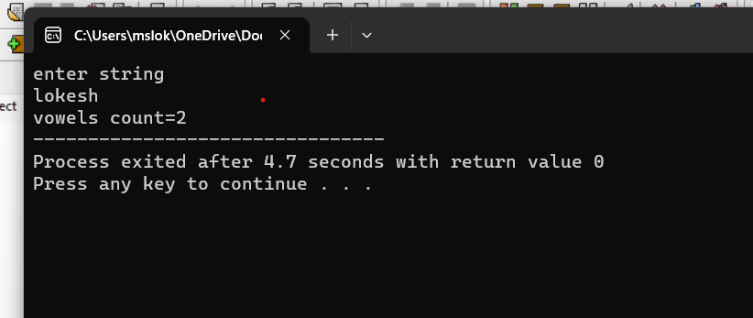

24.MATRIX MULTIPLICATION

Program:

#include<stdio.h>

int main()

{

int a[10][10],b[10][10],r1,r2,c1,c2,i,j,k,s=0;

printf("enter 1st matrix rows and columns\n");

scanf("%d%d",&r1,&c1);

printf("enter 2nd matrix rows and columns\n");

scanf("%d%d",&r2,&c2);

if(c1==r2)

{

printf("enter 1st matrix elements\n");

for(i=0;i<r1;i++)

{

for(j=0;j<c1;j++)

{

scanf("%d",&a[i][j]);

}

printf("\n");

}

printf("enter 2nd matrix elements\n");

for(i=0;i<r2;i++)

{

for(j=0;j<c2;j++)

{

scanf("%d",&b[i][j]);

}

printf("\n");

}

for(i=0;i<r1;i++)

{

for(j=0;j<c2;j++)

{

for(k=0;k<r2;k++)

{

s=s+a[i][k]*b[k][j];

}

printf("%4d",s);

s=0;

}

printf("\n");

}

}

else

printf("matrix multiplication not possible");

return 0;

}

Output:

